DATA STRUCTURE PROJECT



**Airway Control System**

MEMBERS-

SIDDHARTHA GOEL – 17104040

SHIVANG GOYAL – 17104057

RISHI GARG – 17104052

KHUSHAL VYAS – 17104056

SUBMITTED TO-

**DR. Vikas Saxena**

**Problem Statement**

This Project aims at building a basic air-traffic-controller.This project consist of two different classes where airport is our base class and planes is our derived class.There are 11 different airports and are they are connected to few airports only i.e every airport is not necessarily connected to every other airport. A fixed weight is used between airports to set distance between the two. Each airport having an index and mapped to its name using maps.Flights cost is also mentioned and is directly proportional to distance.Thereby, **our project controls the air traffic by finding the shortest path and cost between airports. And controls the reservation and cancellation of flights effectively.**

* To know the shortest path between our source and destination.
* To know the minimum ticket price we can get between two places considering shortest path.
* Number of paths between 2 airports taking no stops into consideration.
* Reserve and cancellation of seats.

This project helped us to gain in-depth knowledge about various data- structures and their use in real world applications like these.

**Data Structures Used**

* Graphs

Used to implement shortest path between airports and the lowest cost for the bookings.

* Map

We used them to map the city index and the name.

* Vector

Used to implement adjacency list. The information about the different locations are inserted as a pair into the vector.

* Queue

It is used to waitlist passengers in case when seats were full. The information about the waitlisted person is inserted as a structure into the queue.

**We have added following several functionalities to our project -:**

1} To know the Shortest Path between the two stops:

We have made a database of a large no. of airports and inserted distance between them using both adjacency list and matrix.

Then,we have used **Floyd Warshall Algorithm**(Data structure Graph) to find the minimum distance between all the routes.

2} Minimum ticket price for the booking:

We have given price as the weight between all the airports and then by using improvised version of warshall's theorem

we have find the minimum ticket price for the booking.

3} Displaying path between two stops:

Using the Floyd Warshall Algorithm we have found the shortest path between the stops and then we have displayed the same.

4} Reserve your seat:

We have asked for the input of the no. of seats the user wants to reserve and then checked for the availability of it by checking the no. of seats already booked and the no. of seats the user wants to book now. And assigned each passenger

unique seatID.

If the seats aren't available then we add their names to the waiting list (**developed by using Data Structure queue**).

5} Cancel booking:

One can cancel their seat by giving his/her seatID and therefore the first waitlisted person gets the booking preference.

6} Booking info:

User can see their booking details by giving his/her seatID.

7} Information about departed flight:

This function is basically for the pilot to check the distance, fuel and time between the places he has to travel.

The time will increase and which will lead to decrease in the fuel and distance between the stops.

**UML Diagram**

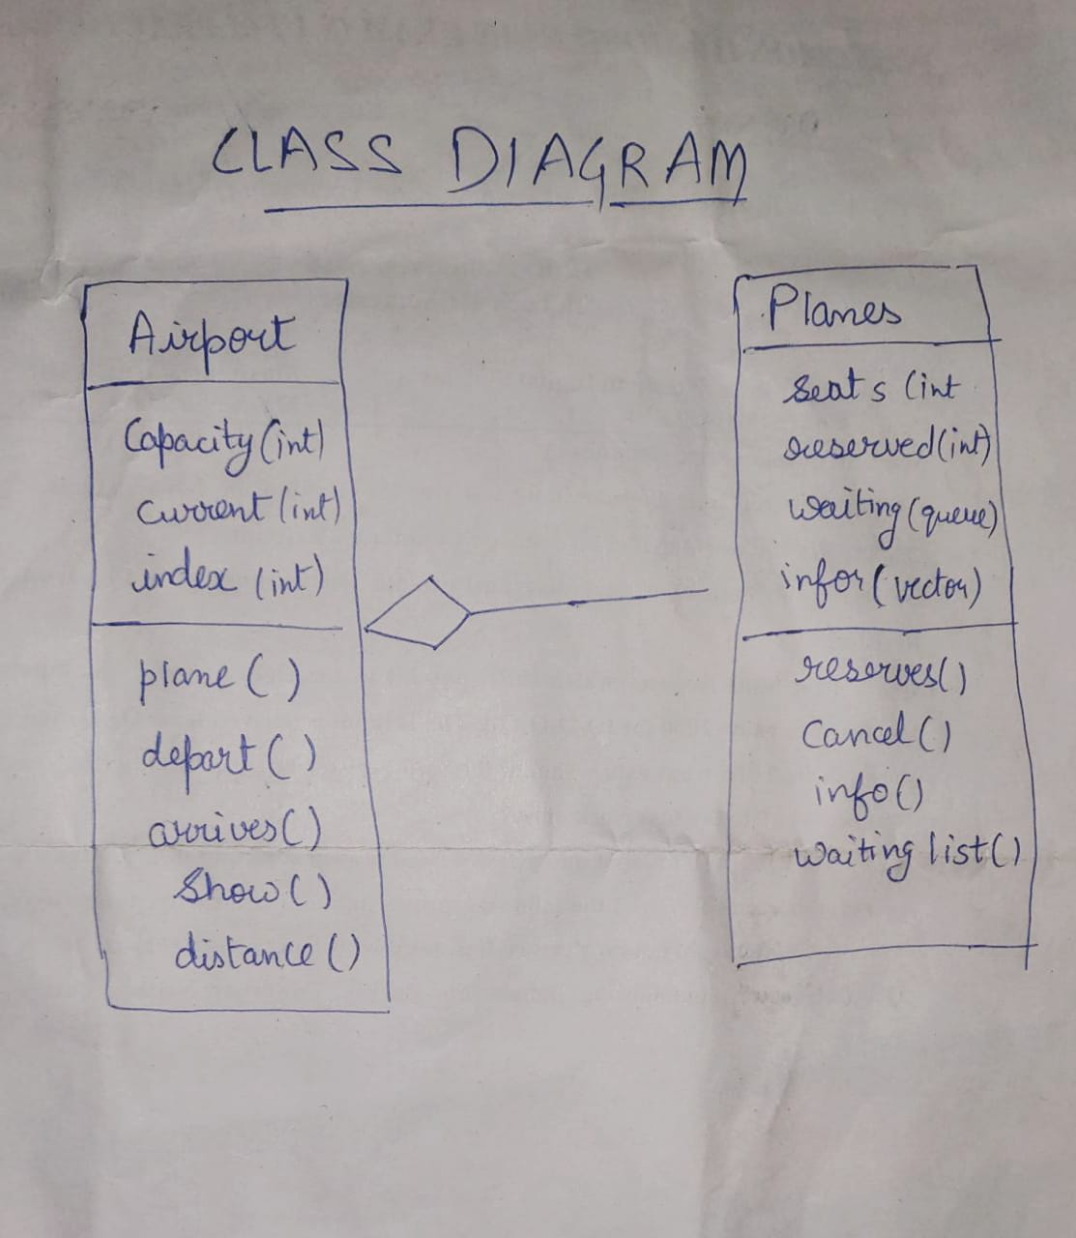

**Project Work Distribution**

Siddhartha and Khushal:

Classes and their inherited functions and classes for the base of the project.

Siddhartha, Shivang and Rishi:

First 3 cases of the main function involving the graph algo.

Khushal:

Developed the functions involving the reservation and cancelation of the booking.

Rishi:

Made the time testing file which would be used by the pilot.

Output Screenshorts:

